**CENTENNIAL COLLEGE   
Information and Communication Engineering Technology (ICET)**

**MID TERM EXAMINATION**

**SEMESTER: WINTER 2017**

**Section 06**

**SUBJECT NAME:** Introduction To Database Concept

**SUBJECT CODE: COMP122 – OPEN BOOK**

**EXAMINATION DATE: FEBR 23, 2017**

**INSTRUCTOR NAME: ERSAN CAM**

**MARKS ALLOTTED: 50 Mark for this Open book part**

**WEIGHTING: 25% of both Mid Term open book and closed book test totals**

**SPECIAL INSTRUCTIONS:**

Exam Books: Required: X Not Required:

Exam Aids: Permitted: X Not Permitted:

Exam Question Paper: Returned: X Not Returned:

**Instructions:**

1. **Rename your file with your name on the file name and MidTerm keyword and drop this word document to dropbox (provided by your teacher) at the end of your session.**
2. **Don’t forget to save this document or SQL Developer work thought out your exam for you to NOT lose your work..**
3. **Answer all questions in exam word file under each question with red color… Copy paste your SELECT statement there and also screen shot of your result from the SQL Developer**
4. **You may answer the questions in any order, as long as they are well identified.**

**Total Marks = 50 (each 10 pnt) Total Duration: 2 hrs COMP122**

**Use Human Resource (HR) tables from our lab environment to answer question 1 and 2**

**Q1. 10 points**

Display each department number and total employee in each department … But when you finalize your report it should only shows departments (department_id) that total employee number is less than four employees … Sort the order as ASCENDING based on department_id:

Hint: **No need for join just use employee table.. But apply group by with its proper Filtering techniques.**

**SELECT department_id, COUNT(FIRST_NAME) Total**

**FROM EMPLOYEES**

**group by department_id**

**HAVING COUNT(FIRST_NAME) < 4**

**ORDER BY department_id ASC**

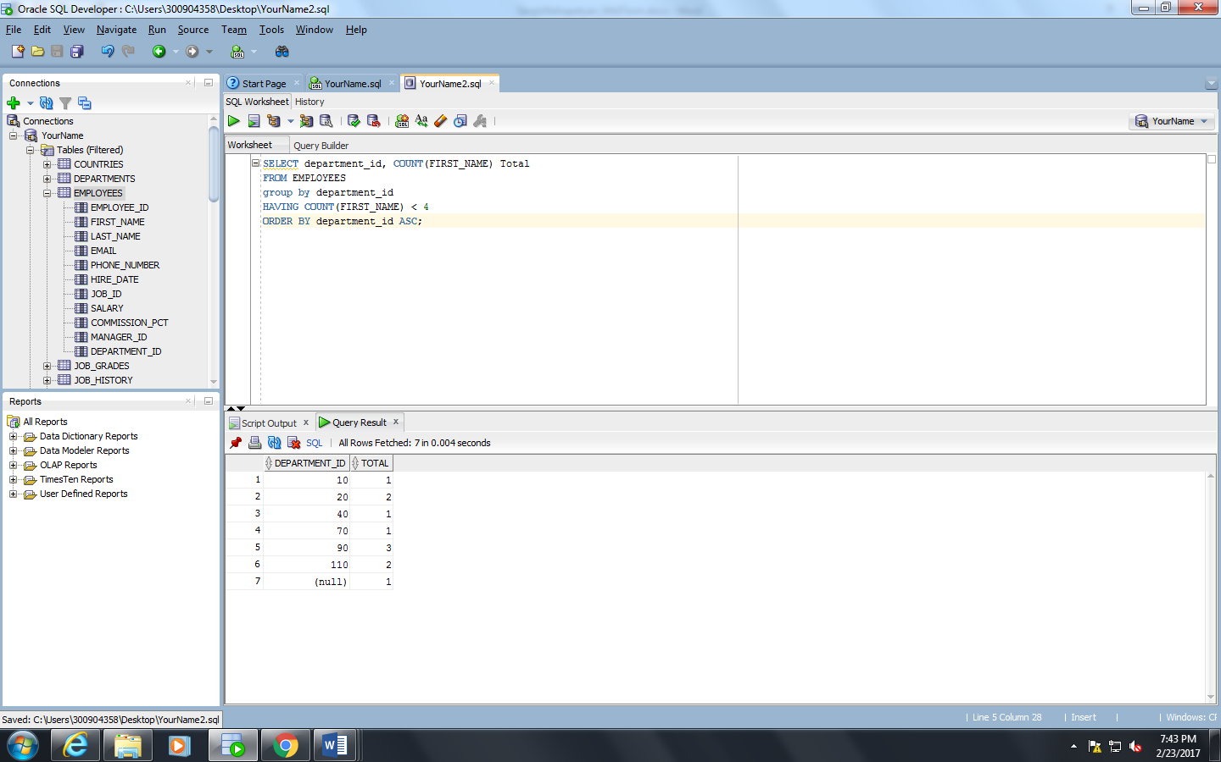

**Q2: 10 points**

Display job ID and average salary for each job ID but when you display your report , as a last filter it should shows only job id’s which average salary is greater than 10,000

**SELECT job_id, AVG(salary) Average**

**FROM EMPLOYEES**

**group by job_id**

**HAVING AVG(salary) > 10000;**

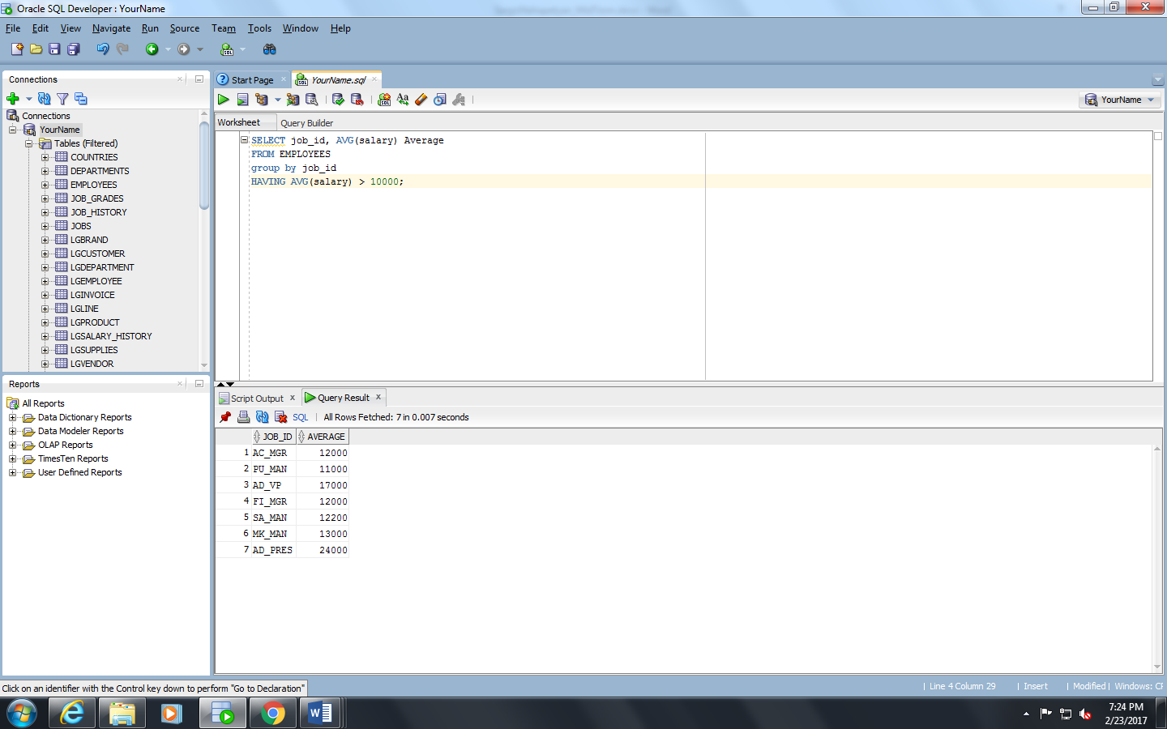

**Q3. 15 points**

Create a report that shows employee number, employee first name, last name, department name, manager_id of that department, location id of that department.

Make sure that the report also includes employees without any department as well

(It means report should show Employees with departments assign and also as well as employees who hasn’t been assigned to any department yet)

SELECT e.EMPLOYEE_ID, e.FIRST_NAME, e.LAST_NAME, d.DEPARTMENT_NAME, d.MANAGER_ID, d.LOCATION_ID

FROM employees e Left OUTER JOIN departments d

on (e.department_id = d.department_id);

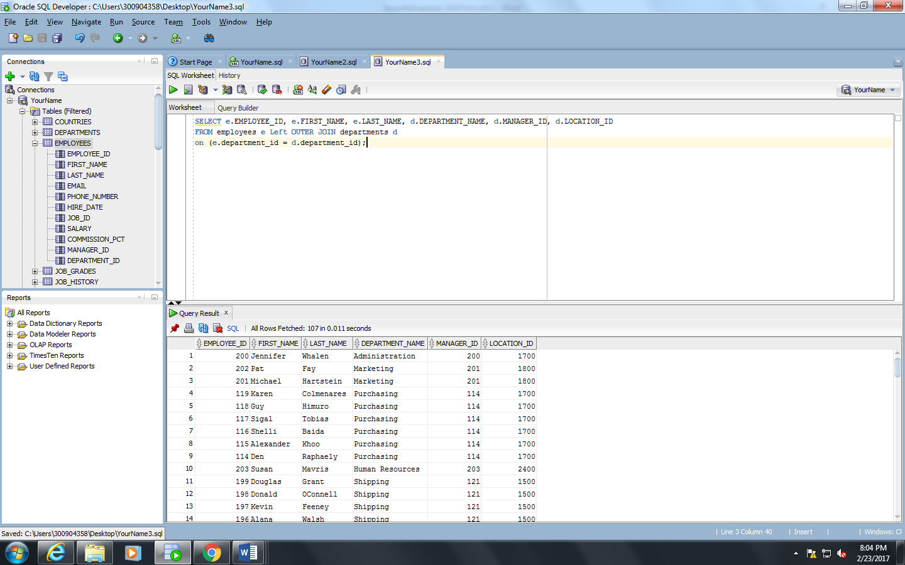

**===============================================================================**

**Instructions for Question 4:**

**Use Attached file to generate LargeCo database sample tables / data to answer questions 4**

**Open Ch08_LargeCo_ORA.txt file copy paste entire content into your SQL Developer editor , Highlight entire screen (Control +A) and execute as Batch (Second Play button from left)**

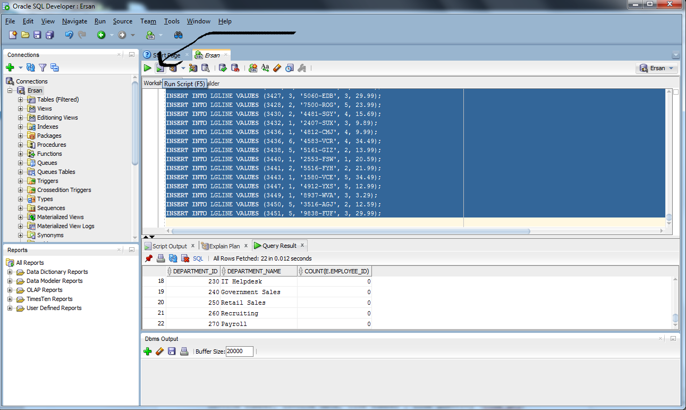

**Q4. 15 points**

Display all the invoice and customer details which is handled by only employee title is 'SENIOR SALES MANAGER' and only with invoice_toal amount is greater than 400 and also only invoice_date is in year 2013

Display these fields (Columns) in your report

Invoice number, invoice date, invoice total , customer first ,cust last name, employee fname, employee lname, employee title

**Hint**: Use LargeCo picture to see the relationship of tables…

JOIN 4 different tables.. Be careful with Primary Key –Foreign key in between these four tables.. Column names may not be exactly same for example emp_num = employee_id

And when you search invoice_date in 2013 use to_char(invoice_date , ‘YYYY’) = ‘2013’ where condition to find them

SELECT n.Inv_Num, n.INV_DATE, n.INV_TOTAL, c.Cust_Fname, c.CUST_LNAME, e.EMP_FNAME, e.EMP_LNAME, e.EMP_TITLE

FROM LGINVOICE n

INNER JOIN LGCUSTOMER c

on (n.CUST_CODE = c.CUST_CODE)

Inner JOIN LGEMPLOYEE e

on (n.EMPLOYEE_ID = e.EMP_NUM)

Where e.EMP_TITLE = 'SENIOR SALES MANAGER'

AND n.INV_TOTAL > 400;

